|  |
| --- |
| **ワールド・ブディスト・ミッション**  World Buddhist Mission  7th International Conference on South East Asian Studies  20th October – 22nd  October 2022 |
| Conference Venue  City of Tsukuba Post 305-8555.Tsukuba [http://www.city.tsukuba.lg.jp](http://www.city.tsukuba.lg.jp/) JAPAN |

**In cooperation with INDIAN COUNCIL OF PHILOSOPHICAL RESEARCH,DELHI,INDIA**

**23rd OCTOBER 2022**

Courtesy tour to Big Buddha Image at Ushiku Ibaraki, Japan

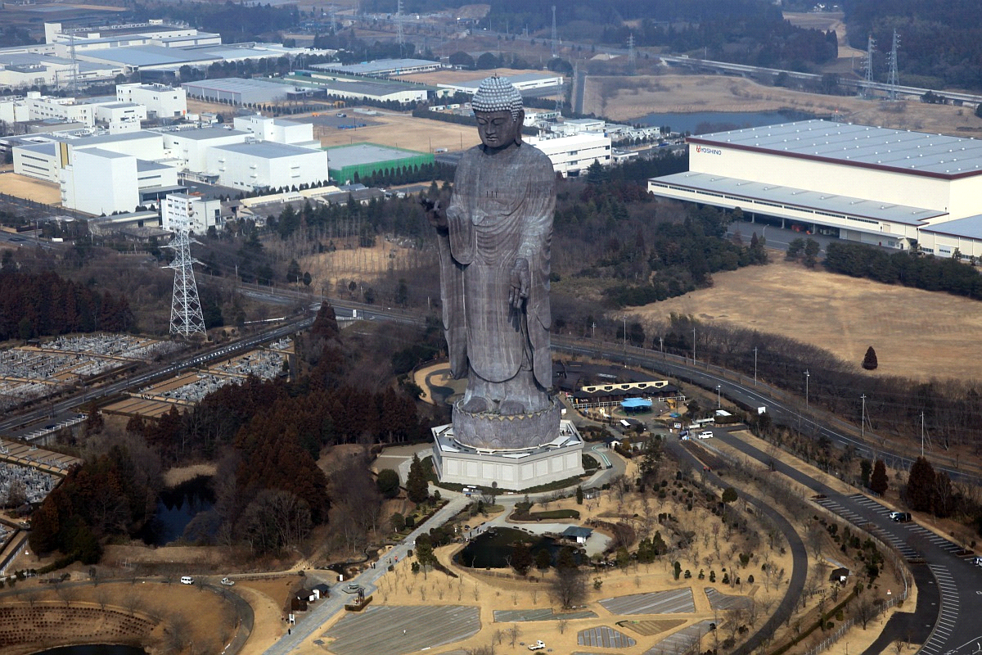

**24Th OCTOBER 2022**

06:30 am: Breakfast.

07:00 am: Start from OKAYAMA City to HIROSHIMA City.

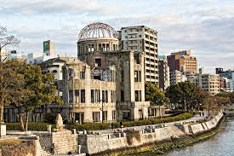

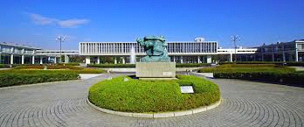Visit Heiwa Park (Peace Memorial Park), Museum Origami Center.

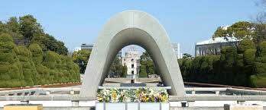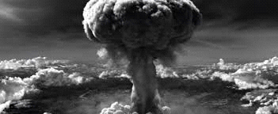

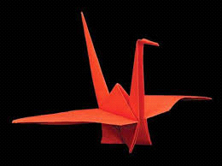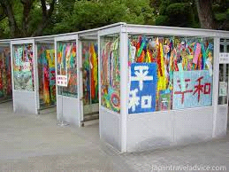

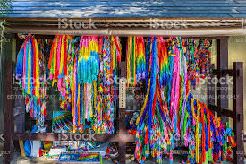

* Offer Origami and Pray For the World Peace.
* Night Bus to Kyoto

**25th OCTOBER 2022**

* 07:00 am: Arrival at Kyoto and Check-in in Hotel.
* 08:00 am: Breakfast
* 09:00 am: Start for Gold Temple (Kinkakuji). Stay here for two hours. And go around the Temple and visit shopping centers.

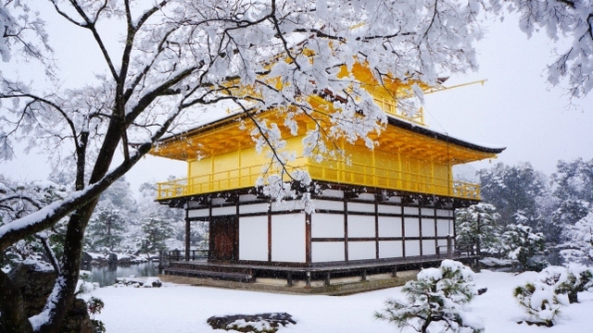

* 11:00 am: Start for Gingkakuji (Silver Temple).

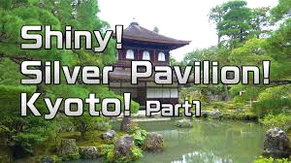

* Stay here up to 12:30 pm for Lunch.
* 13:00 pm to 14:00 pm: Lunch.
* 14:15 pm: Move to Kiyomizu-Dera.
* Go around the temple and visit different locations enjoy Kyoto special Dishes specially produced at Kiyomizu-Dera.

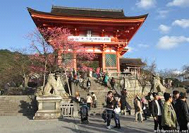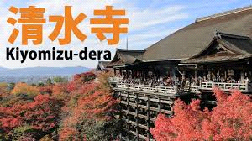

* 16:30 pm: start for Kyoto tower, Kyoto Station and nearby Shopping center.

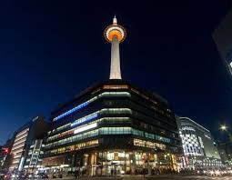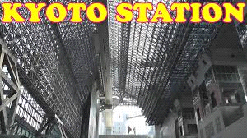

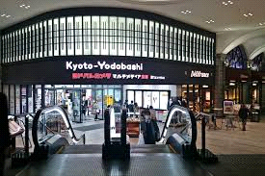

* 18:30 pm: Visit Gion area and visit traditional Geisha Girl Center.
* 19:30 pm: Dinner with Japanese Kyoto Traditional Show and Night stay at Kyoto Hotel.

**27th OCTOBER 2022**

* 07:00 am Breakfast and start for NijoCastle.

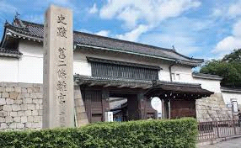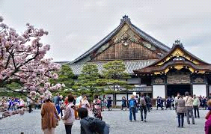

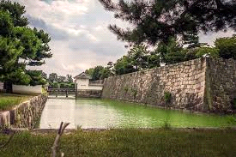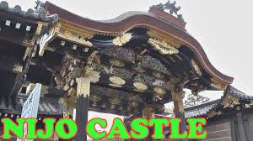

* 10:00 am: start for Koyasan temple in Osaka area and lunch on the way to Koyasan.

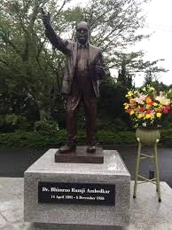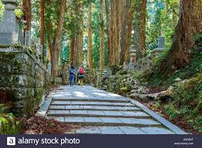

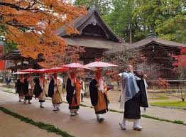

* 14:00 pm: Arrival at Koyasan and Check-in in hotel.
* 15:00 pm: Visit Dr. Ambedkar Statue at Koyasan & pay Homage
* 16:00 pm: start for forest walk at Koyasan.
* 19:00 pm: Dinner at Hotel and enjoy Night view.

**28TH OCTOBER 2022**

* 07:00 am: Breakfast and visit Koyasan University.

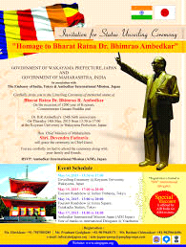

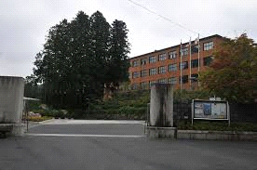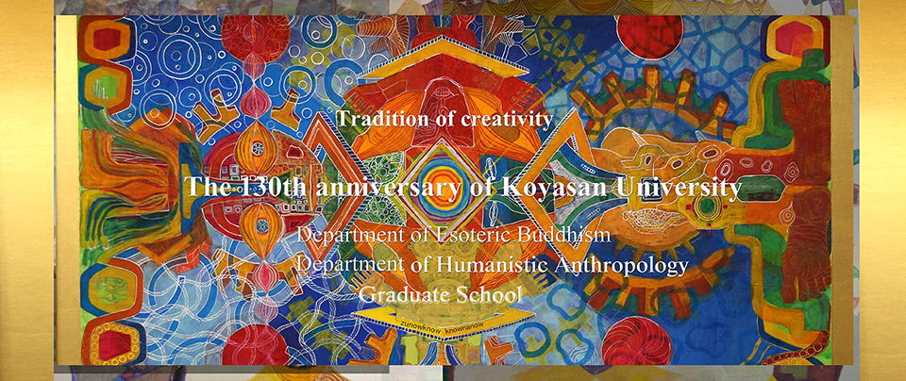

* 9:00 am: Start for Osaka Disney center and Universal Studio.

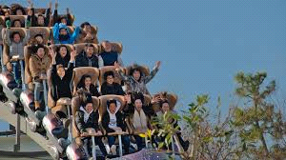

* One day at the center and evening free for Shopping at near Osaka JR Station, end of the tour and start for own Destinations.

MATA AI MASHO (let us meet again).

**TERMS AND CONDITIONS FOR POST CONFERENCE TOUR:**

Tour cost $1950 USD or equivalent foreign currency.

**Deadline of Booking: 15th Sept 2022.**

Tour cost includes travel by Ac Buses/Bullet Trains/Pickup van cost includes Standard Hotel on twin sharing Basis. All main meals that are Breakfast, Lunch and Dinner. Tour cost not includes any entrance fee, personal expenses, and laundry etc.

* Early bird offer $1500 USD booking done Till FEB 2022
* Silver bird offer $1750USD booking done till MARCH 2022
* Last moment booking $2000 USD.

Note:

1.Refund of tour cost can be done 30TH MARCH 2022 and administrative fee will be deducted USD $ 50 or ¥ 5,000 JPY.

2. Extra two days tour in Tokyo on twin sharing basis $ 250 per pax.

3. Date can be change without prior notice on the demand of Enrolled guest.

4. all right reserved world Buddhist Mission Japan